0-2 - Active Me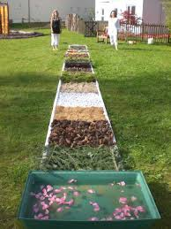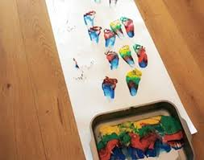

Activity: Sensory Walk
What to do? Encourage your child to walk with bare feet or crawl through different textures.
Textures you can use: Paints, sand, water, foam, cooked pasta, beans, spaghetti, flour, grass, mud, leaves etc.
Where Can you do this if you don’t have access to trays? Outside in the garden or on a hard floor (you can place clingfilm on the floor so its easy to clean away)

Once the walk is over your child can continue to play exploring all the different textures using their whole bodies.

