My Emotion’s

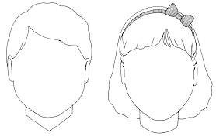

Talk to your child asking them how they are feeling. Children can then use different resources to create a picture of themselves with a smiley face, a sad face, a tired face, an angry face or an excited face. To decorate the face you could use paint, crayons, felts, playdough, peas, different cut up fruits etc.
