Talking Time
Sensory Messy Play
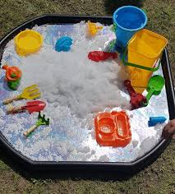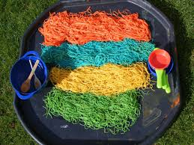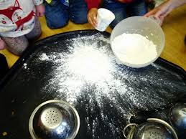

Where to put the messy play?
Sink, Bathtub, tray, bowls
What I could use?
Soap, foam, sand, water, spaghetti, beans, pasta, flour, cornflour and water, Weetabix and milk, Paint etc.
Props
Dolls, Play animals, cars, cups, spoons, brushes.
Key words and sounds to use
Woosh, swish, swoosh, squidge, tap, pat, wet, cold, hot

